QB WHISPERER

I want to thank Joe Montana, Steve Young, and Dan Marino for helping me put together this document. If you read everything and put everything into practice, you will be an unstoppable QB in whatever level you play at whether it’s high school, college, or the NFL.

- Congrats, you are an NFL QB. This position comes with hype and responsibility. You will be criticized by the media. So identify the emotions you feel, positive and negative. Navigating these negative 8 emotions are key to success in the NFL. They are sadness, shame, helplessness, anger, vulnerability, embarrassment, disappointment, and frustration. Notice when you feel these emotions. Don’t let them get you down. Also, focus more on your work and practicing while spending less time on what the media says about you.

- Money changes you. You must practice and focus on football 10-12 hours a day your first three years. This means spending 4-6 hours getting reps in with teammates. Watch this video starting at 10:00 on why Ryan Leaf failed at QB. It’s best to spend your time focusing on football rather than spending your money. https://bit.ly/3raABXo
Watch why Jamarcus Russel failed: https://www.youtube.com/watch?v=s0Xy960CF-k
Watch why Johnny Manziel failed: https://www.youtube.com/watch?v=irHqpj8i7t0
Watch why Ryan Leaf failed: https://bit.ly/3dNIgYP
Watch why Tim Tebow failed: https://bit.ly/3UGKKZz

- You must practice not getting injured. Be aware of bodies around you, especially near your knees and ankles. If you see DE or rushers near your legs jump up so your feet don’t get implanted in the ground and cause you to blow a knee or break an ankle. Also, make sure you slide when running with the ball so you don’t get injured while scrambling down the field. https://www.youtube.com/watch?v=jrnS1WuthIA
Dak Injury: https://www.youtube.com/watch?v=lppI6tc-zVY
Tom Brady Injury: https://www.youtube.com/watch?v=tzQVmZDXS4w

- If we want to succeed, we should study QBs who failed in the NFL. Asking yourself why these guys failed is a good question. Many of these guys dominated in college and have big arms and were accurate passers. I believe the difference maker is having an insane work ethic. This means spending 4-6 hours a day in your first two years to get reps with your teammates so you can develop accuracy, anticipation, and know your playbook without a shadow of a doubt. You should also know what your teammates are doing and you eventually need to learn how to coach up teammates such as OL, RB, WR, FB. Watch this video to see countless failures so you can succeed. https://www.youtube.com/watch?v=zS-Og_RfdNc

- In the NFL, you must put the ball on a tight 12”-16” diameter circular window or on the numbers. Insane accuracy is required to dominate in the NFL. Request your coach to give you reps in practice for 4-6 hours a day to develop deadly accuracy and anticipation. Come in early and stay late to slow the game down and make it easier for you to play and dominate. Sometimes rookie QBs don’t work with their coach and teammates to get in the work it takes to slow the game down. All the greats I have talked to from Dan Marino, Joe Montana, Steve Young, and countless others all had the same thing happen. They all spent 12 hours a day in practice getting reps, studying their play book, watching film of their last game to pick it apart and dissect every play they made in their game looking for weaknesses and areas to improve. Last, they watch their upcoming opponents' last three games looking for weaknesses, mismatches, nuances, and fundamentals that give you an edge in the next game. Ask your coach for help analyzing football so you will be the most prepared guy on the field week in and week out.

- For the first 3 years in the NFL, these great Super Bowl winning QBs made their whole life revolve around one thing.. FOOTBALL! It’s this insatiable desire to win, learn, and thrive that drives the greats. Putting in the time, going above and beyond is what it takes to be great, win Super Bowls, and carve out a legacy in the NFL. When people say your name, what do you want them to think? When you hear the name “Tom Brady,” what do you think? Work your ass off like Tom Brady did his first three years in the NFL. He asked countless questions, practiced with teammates and was rewarded with multiple Super Bowls. Then he did it again, and again, and again winning 7 total Super Bowls. Let’s give your name a legacy just like the greats.
- Must be accurate. Russel Wilson illustrates how accurate one must be at 5:50 in the below video. https://www.youtube.com/watch?v=TGUMFbArIKk

- Great QB’s to study. You can find their videos on Youtube. By learning about and studying these champions, you will download each of their unique playing style so you can apply what you learn from them and use the knowledge you gain to develop and build your playing style and brand: https://bit.ly/3DOz0hv

- I reiterate, put the ball on your target with deadly accuracy and anticipation. This is the essence of being a QB in the NFL. If you find you aren’t hitting passes in either of the short, middle, and long distances, keep practicing and getting reps in until it’s second nature. The greats don’t stop until they feel 100% comfortable with every throw.

- Analyze your film so you can see what passes you made, and what passes you failed at. Then put in the hours with your receivers to make great throws second nature. If you develop a sore arm use “pliabilty” like in the video below. Massage your arm before and after practice to strengthen tendons and muscles so your arm doesn’t get sore, allowing you to practice longer and gain an edge on the competition. https://www.youtube.com/watch?v=Onv8haGHHss

- Tim Grover-Micheal Jordan and Kobe Bryant's trainer-allowed me to put his mentality tapes on my website. They are so key to developing a killer mindset to be an athlete that goes above and beyond. This is what the top NFL players do, spending 10-12 hrs a day honing their craft, and allowing them to dominate. These tapes give you permission to be selfish, hungry, and with time, become great. https://bit.ly/3LQw3yV

- You must develop your “Sports Psychology” studies so you can stay motivated and hungry. Do this at my website by reading through cliff notes I took from autobiographies I read of some of the greatest players of all time including Bill Belichick, Nick Saban, Tom Brady and more! https://bit.ly/3Si8B07

- Place your hand on the ball the same way every time. This will make it so you develop consistency knowing exactly how your hand covers the ball.

- Always use your head to analyze and grind every Sunday.

- Always use your eyes to make plays happen. You can fake right, then pass left. You can do this when you are passing. Look right, move the safety, then look left to throw at your target.

- When you look left, you can keep your eyes on your passing target that’s on your right using your eyes and partially your peripheral vision. You can expand your vision by seeing things in your peripheral vision. For example, you can hold up your hands in your peripheral vision with a number. For example, hold up the number “2.” Then, see the number 2 in your right hand, and call out the number two. Then change it to the left hand in your peripheral vision, and call out the number being held up in your left hand.

- Look right, pump fake. Pass left to open receiver.

- Do the above constantly to become ultra comfortable with your eyes and your head. The eye also has 4 ligaments that need to be stretched out. By practicing using your eyes like this for an hour or a bit longer, the ligaments on the outside of the eyes will stretch making it super easy to do and to control.

- Use your eyes and brain to win the chess match.

- Go into every pass with the goal of making every pass you throw.

- Be a perfectionist. Do everything with the intention of making the best play on the field.

- Never let someone else's opinion interrupt your game flow. Do this by being the best player on the field at all times.

- You must always be on time to practice, games, and meetings.

- Checkout my course to control your brain called Brain Reframe.

- You must always help or coach up your teammates to get the best out of them. Thus, making your team as good as possible to break through the ceiling.

- Find a player on your team to practice throws with. Have them run routes to perfect everything. Must leave no stone unturned. Practice getting reps for 3-5 hours.

- You must find everything you do in life revolves around your play in the NFL on Sundays.

- Be able to see the field while you are also seeing your left tackle for a right handed
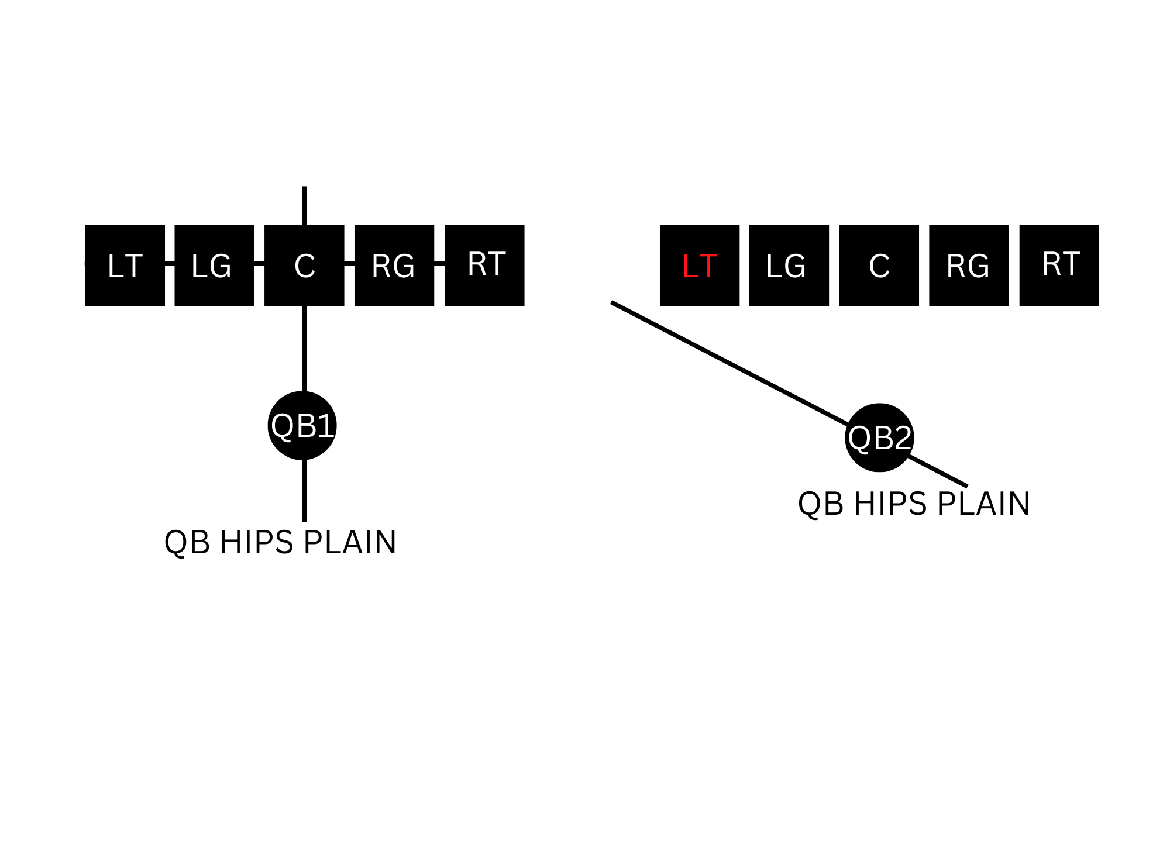
QB, or the right tackle for the left handed QB is key! Do this by keeping your hips open to where you can see your left tackle in your peripheral vision. Rather than having your hips perpendicular to the OL like QB1 in the diagram below. Have your hips open like the QB2 in the diagram. This allows you to see the whole offensive line in front of you (including your LT) while you are looking for a receiver downfield. Then you don’t have a blind side and can have better pocket presence that will allow you to escape the pocket and avoid sacks. QB1 hips point at 0 on a clock. QB2 hips point at 10 on a clock. Watch Aaron Rogers film as he keeps his open like QB2 so he can see his LT and avoid sacks

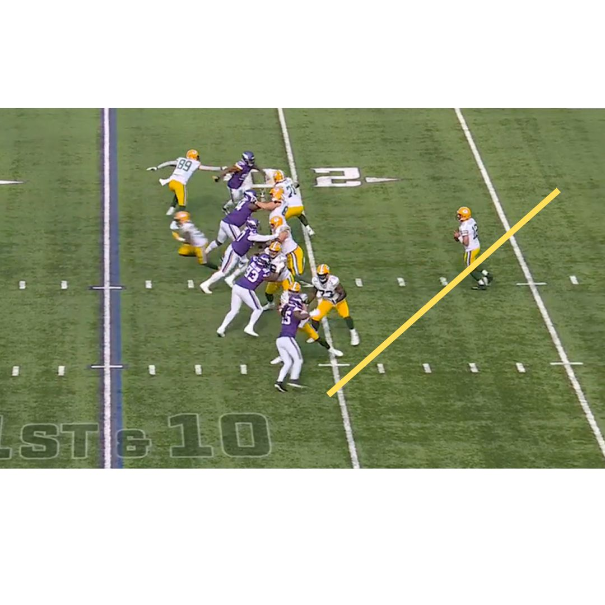
- You must focus your eyes or gaze on a point that is in front of you, and is a little to the right. If it’s a clock, your gaze should be on 1 o’clock. Then you can see the whole field and receivers in your peripheral vision. This makes the game easier and helps you make better decisions with the ball.

- You must be able to look directly down the field and see all 3, 4 and 5 wide receivers in your vision. Essentially, you can stare at a focal point and use your peripheral vision to see all your targets and opponents.

- If you want to move a Safety, you can do this by looking right, holding your head there. Move the safety to the fright. Then, move your gaze in the opposite direction and hit your open target. So, to sum this up, if you want to hit a receiver on the right, look left first, pump fake, then go right.

- Use pump fakes to freeze CB and Safeties. If you are going to throw left, pump fake right. You can even use multiple pump fakes to mess with defenders.

- Throw the ball hard with Umpf like Brett Favre and John Elway. This makes it harder for CBs to intercept the ball. https://www.youtube.com/watch?v=rGJOMkOUbTM&t=318s

- Must work on accuracy by having a receiver stand still and throw the ball at this person distances of 10, 20, 30, 40, 50, 60 yards. Keep track of how many balls were on target in the right spot aka on the receivers numbers.

- Then have someone run routes distances of 10, 20, 30, 40, 50, 60, 70 yards and calculate how many balls were on target in the right spot. Hitting your targets with someone running a route allows you to practice and develop anticipation.

- Incredible accuracy and anticipation is what great QB’s develop. Throwing an accurate ball with pace and anticipation is key. It’s easier said than done.

- Once you develop these skills, then you can hit your receivers on target no matter the distance. This is how you develop to be a top tier QB.

- QBs can't be scared to throw the ball into coverage to give your WR a chance.

- Cornerbacks don’t look for the ball. This fact always gives you a chance to connect with your receivers as long as you put the ball in the right spot.

- Practice as much as you need to each day working with WR, CB, S, and RB. This makes it easier to put the ball on the money without thinking like the top QBs do consistently.

- Before each play the QB must recognize all the opponents at each position and who’s guarding who: DL, LB, CB, S. You can also identify mismatches, aka WR or RB guarded by a LB or S.

- The QB must also know exactly what his teammates will do for every play whether it’s passing or rushing. He should know the playback like the back of his hand. And be able to help coachup his teammates.

- Where to hold the ball? Hold the ball over your numbers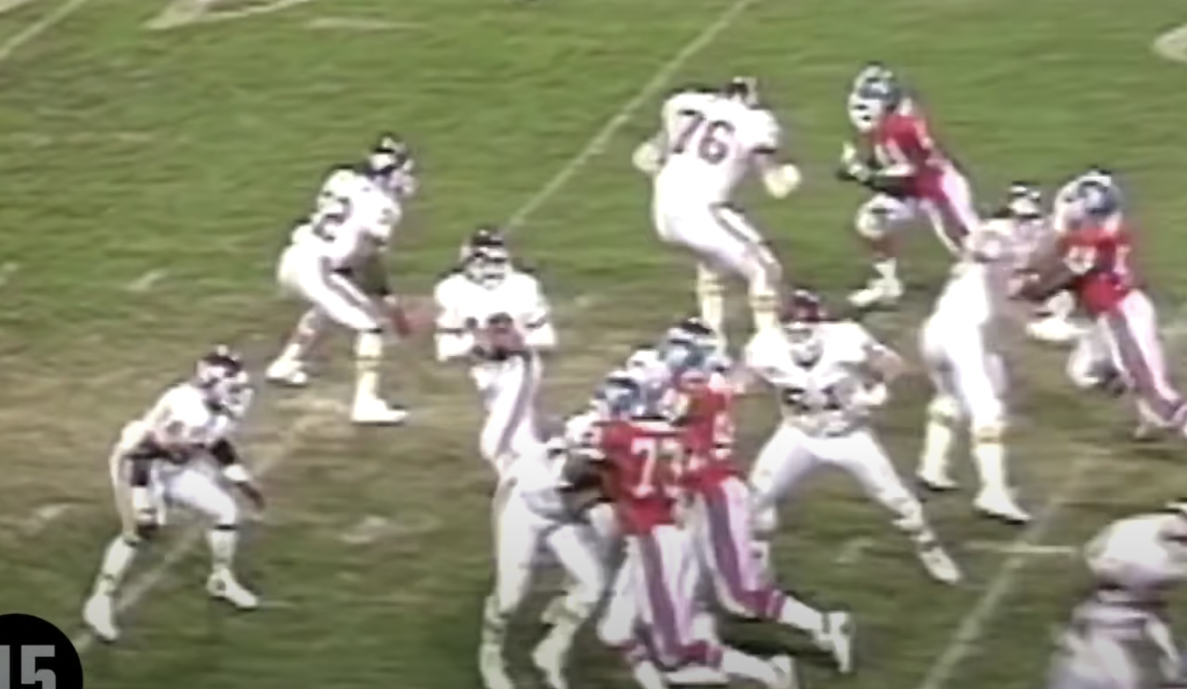

- How to throw an accurate pass? Have your throwing arm finish pointing toward your target.

- Don’t have your left hand up because this shows where you are planning to throw the ball or where you are looking. Your left hand is an extension of your head giving defenders extra clues on where you are planning to throw the football. It’s best to keep two hands on the ball in case a DE or DL sneaks in there and swats your hand to cause a fumble.

- When under duress, do short passes, shuffle back 6-8 yards, catch the shotgun pass 5-6 yards back giving yourself more space. Don’t be afraid to roll out of the pocket.

- See opponents defense before each play and identify what formation they are in to give you an advantage.

- Practice analyzing defenses by having your D line up in the different formations and you call them out in practice. Identify players by numbers. DL-90-99, LB 40-59, CB 01-20, S 20-30.

- It’s also imperative you know the playbook and what role your teammates have in the game. If you don’t know your playbook in and out, you are putting your team at a disadvantage.

- Sit down and learn your playbook. Work with your teammates to help them know the playbook inside and out. The best of the best are the most prepared players on the field.

- Must hold the ball with two hands. https://youtube.com/shorts/dC63D5s_xtY?feature=share

- Not afraid to throw the ball down field. DBs don't turn their heads around. If it gets picked down the field, it's like a punt.

- Tracking Dummies for precision passing. https://www.youtube.com/watch?v=_z5U-3vSgO

- Buy dummies. https://www.sportsunlimitedinc.com/fisher-pro-pop-up-football-dummy.html?Color=Red&utm_source=google&utm_medium=cpc&country=US&CID=PPC&gclid=CjwKCAjw3ueiBhBmEiwA4BhspFJ5twZSa6PO1bYlkzGWu0Clo9AccYaCRdtfCOPswFSRKY6bUt_p4BoCatYQAvD_BwE

- Duck to draw roughing the passer penalties.

